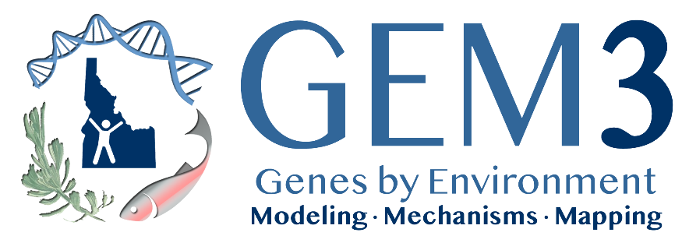

GEM3 Lab Module Design Workshop (Save the Date)

Monday, July 29th 2:00-5:00 pm (MST)

Lookout Conference Room – BSU Student Union

Overview: The objective of this workshop is to facilitate collaboration among Idaho University RII lab module developers and two and four year institution (Primarily Undergraduate Institutions; PUIs) faculty to ensure integration and transferability of GEM3 lab modules, including the integration of modules with VIP courses and future plans. The workshop will provide an overview of planned and established lab modules and will use a "hands-on" approach to facilitate cross site collaboration to articulate, adapt, and deliver lab modules at Idaho PUIs. **The workshop is scheduled to take place the afternoon before the ICUR conference which is July 30-31; also scheduled at Boise State University.
Travel: The ESPCOR GEM3 grant has funds available to pay for participants travel, lodging, and per diem for this workshop. Participants will be reimbursed after event and will be provided additional information closer to event date.

Who Should Attend: GEM3 VIP lead faculty and graduate students, University Graduate Students and faculty who are developing lab modules, PUI faculty, and others involved in creation and implementation of VIP lab modules

Meeting Objectives:

- Inform PUI participants of existing (year 1-2) VIP courses and projected availability for integration into PUI courses
- Establish a “Mapping” strategy (that links to VIP/SRE recruiting website) to identify how specific lab modules lead to/connect to certain VIP courses. For example – “if this (lab module) is interesting to you – you can enroll in a VIP at (whatever institution is offering that particular VIP course of interest)”
- Collaborate to develop context and information to help PUI faculty to associate lab modules and their delivery of GEM3 material, to VIP course offerings and Summer Research Experiences (SREs) at universities (i.e. objectives of labs should link to GEM3 projects, WFD skill sets and inter-university/opportunities that students can seek if interested)
- Develop a strategy and timeline for notifying PUI participants of upcoming VIP courses in order for PUI faculty to better align their course offerings (i.e. power point with synopsis, inter-university/college site visits)
- Identify and initialize ways to bring in other PUIs (on-ramps) into VIP activities
- Establish and develop partnerships between PUI faculty and institutional RII faculty to facilitate receiving and delivering lab modules and to ensure PUI capacities are fully understood and integrated into lab module planning
- Provide information about and Summer Research Experiences (SREs), their development and various recruitment strategies

Contact: If you are interested in attending, please contact denisepfeifer@boisestate.edu

